ECS30

Linux

Assignment 3

Chengeng Xiao

SID: 913186040

1, (*5 points*) How do you determine who is logged into the CSIF system you are using?

Enter command : “users”

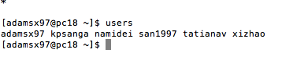

2，(*7 points*) Write a UNIX/Linux command to print dictionary words that contain the vowels ‘a’, ‘e’, ‘i’, ‘o’, and ‘u’ in that order. The vowels may be upper-case or lower-case. *Hint*: The file “/usr/share/dict/words” is a dictionary of English words. The command *grep*(1) may help you.

First go to folder /usr/share/dict find words file. Then enter:

grep -E "^[^aeiouAEIOU]\*[a|A][^aeiouAEIOU]\*[e|E][^aeiouAEIOU]\*[i|I][^aeiouAEIOU]\*[o|O][^aeiouAEIOU]\*[u|U].\*" words

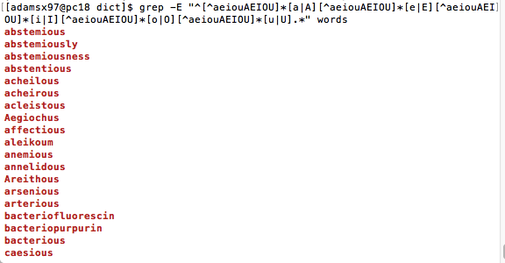

3, (*5 points*) What is the file “/etc/motd”? When are its contents displayed?

It displays CSIF’s information.

